**AI and Blockchain-Based Certificate Verification System**

**(Project Proposal)**

# Project Code

BCV-AI-(25-26) **Project Advisor**

Mr. Muhammad Fahad

**Project Manager**

Dr. Muhammad Ilyas

**Project Team**

Muhammad Nouman Riaz BSCS51F21R003 (Team Lead / Team Member)

**Submission Date**

October 6, 2025

# Table of Contents

1. Abstract................................................................................................................................. 3
2. Background and Justification................................................................................................ 3
3. Project Methodology..............................................................................................................3
4. Project Scope........................................................................................................................4
5. High level Project Plan..........................................................................................................4
6. References............................................................................................................................5

## 1. Abstract

In Pakistan’s professional and academic sectors, certificate fraud is becoming an increasingly serious issue. Fake certificates often go undetected because manual verification methods are unreliable, expensive, and slow.

This project proposes an AI and Blockchain-Based Certificate Verification System that uses modern technology to automate the verification process. The system employs Tesseract OCR to extract text from certificate images and generates SHA-256 hashes as unique digital fingerprints. These hashes are then stored on the Ethereum testnet blockchain, creating tamper-proof records.

When a certificate is uploaded for verification, the system instantly checks its authenticity by comparing its hash with the records stored on the blockchain. Employers and universities can use this web-based platform to verify credentials instantly, while institutions can register and manage verified certificates with ease.

By combining AI and blockchain technology, the system makes verification faster, secure, and accessible while reducing fraud and building trust in credential authentication.

## 2. Background

Certificate fraud has become a serious problem in Pakistan, threatening both professional credibility and academic integrity. Job and university applications increasingly include forged degrees and documents. Manual verification processes are extremely slow, often taking more than two weeks to complete, and institutions frequently ignore verification requests [1].

Research shows that a large number of certificates contain inaccurate or falsified information, yet most organizations lack the proper tools to detect these fraudulent documents . As a result, universities and employers who unknowingly accept underqualified candidates face significant risks.

Blockchain technology offers a solution to these problems, as demonstrated by international initiatives like MIT’s Blockcerts. Such platforms enable instant verification and create tamper-proof records using decentralized systems [2].

**Justification**

Our AI and Blockchain-Based Certificate Verification System will solve these issues by providing fast and reliable verification tools. The system uses Tesseract OCR to extract text from certificates and generates SHA-256 hashes as unique identifiers. These hashes are stored on an Ethereum testnet blockchain, creating permanent records that cannot be altered. When verification is needed, users can instantly compare certificates against blockchain records through our web platform. This eliminates manual work and long waiting times. The system will make verification accessible and efficient while reducing fraud across Pakistan's academic and professional sectors [3].

# 3. Project Methodology

Our AI and Blockchain-Based Certificate Verification System requires iterative development, continuous testing, and regular improvements based on real-world feedback. For this reason, we adopted the Agile (Scrum) methodology. With each development cycle, system accuracy improves as the core verification process is incrementally trained and validated.

Agile’s flexibility allows us to prioritize the main OCR-based certificate extraction module first, then gradually integrate secondary features—such as smart contract deployment, blockchain hash storage, and the verification interface—while maintaining system security and reliability. This approach ensures that a functional, tested, and validated verification solution is delivered, making it ideal for a single developer handling a complex, multi-component project within a four-month academic timeline.

## 4. Project Scope

A structured timeline that outlines the sequence of activities, milestones, and deliverables for developing the certificate verification system

**In-Scope Deliverables:**

## Core Feature: Certificate Verification System

1. Web-based Upload and Verification Interface
2. OCR-Based Text Extraction
3. SHA-256 Hash Generation and Blockchain Storage
4. Verification Module with Hash Comparison
5. Basic Database and Admin Panel

**Out-of-Scope Deliverables:**

1. NO mainnet blockchain deployment, cryptocurrency payments, or token-based systems.
2. NO mobile application development or cross-platform native apps.
3. NO third-party integrations including university systems, ERP connections, biometric authentication, or IOT devices.

**5. High level Project Plan**

## PHASE 1: PLANNING & DESIGN

* Requirements gathering and system architecture design
* Database schema design and technology stack selection
* UI/UX wireframes and web interface design

## PHASE 2: FRONTEND & BACKEND DEVELOPMENT

* Build web-based certificate upload and verification interface
* Develop Flask backend with routing and API endpoints
* Create SQLite database for storing certificate metadata
* Implement basic admin panel for institution management

## PHASE 3: OCR & HASH GENERATION

* Integrate Tesseract OCR for text extraction from certificate images
* Develop SHA-256 hash generation module for digital fingerprints
* Test OCR accuracy with sample certificates and refine extraction logic

## PHASE 4: BLOCKCHAIN INTEGRATION

* Setup Ethereum testnet (Sepolia) environment
* Write and deploy smart contract for hash storage
* Integrate Web3.py for blockchain connectivity • Test hash storage and retrieval from blockchain

## PHASE 5: VERIFICATION MODULE

* Build hash comparison logic for authenticity checking
* Develop verification interface with result display (valid/invalid/tampered)
* Integrate all modules into complete working system

## PHASE 6: TESTING & DOCUMENTATION

* Comprehensive system testing (functional & security)
* Bug fixes and performance optimization
* Complete project report and user documentation • Deploy prototype and prepare demonstration

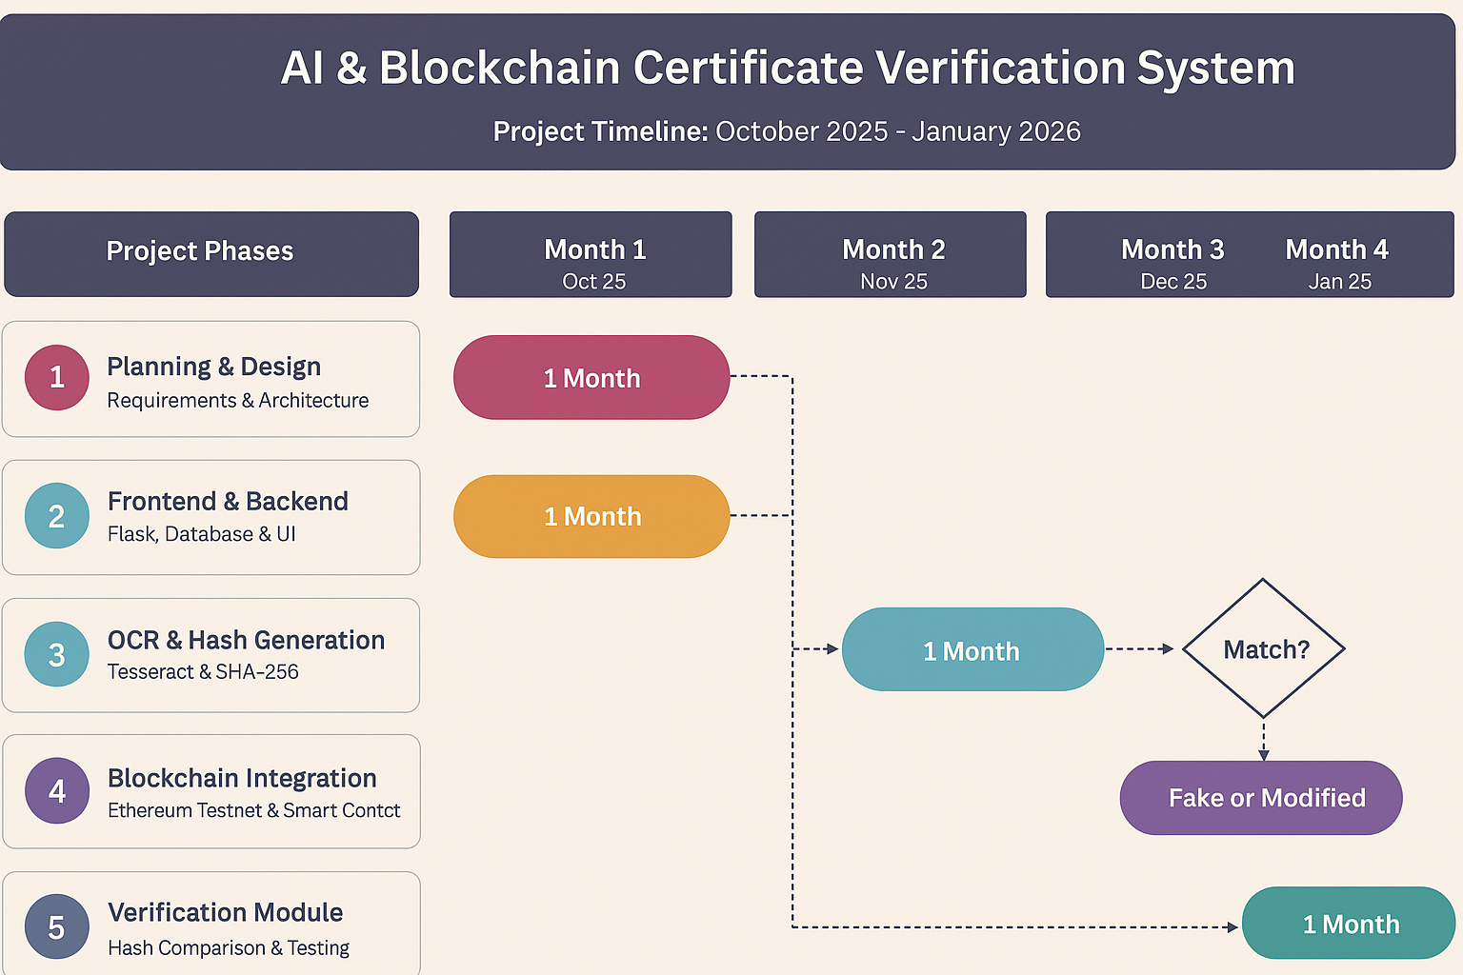

# 6. References

1. R. Haq, “After 15 years: HEC still lacks proper mechanism to verify degrees,” The Express Tribune, Islamabad, Pakistan, May 22, 2017. [Online]. Available: <https://tribune.com.pk/story/1416602/15-years-hec-still-lacks-proper-mechanism-verify-degrees> A. Khan, "The impact of fake degrees on employment quality in developing countries," *Int. J.*
2. J. C. Sharples and J. Domingue, "The blockchain and kudos: A distributed system for educational record, reputation and reward," in *Adaptive Learning in Practice*, Berlin, Germany:

Springer, 2016, pp. 490-496. [Online]. Available: <https://doi.org/10.1007/978-3-319-45153-4_48>

1. E. Durant and A. Trachy, “Digital Diploma debuts at MIT,” *MIT News*, Oct. 17 2017. [Online]. Available: [https://news.mit.edu/2017/mit-debuts-secure-digital-diploma-using-bitcoin-blockchain-technology-1017](https://news.mit.edu/2017/mit-debuts-secure-digital-diploma-using-bitcoin-blockchain-technology-1017?utm_source=chatgpt.com)